Oregon Association of Student Financial Aid Administrators
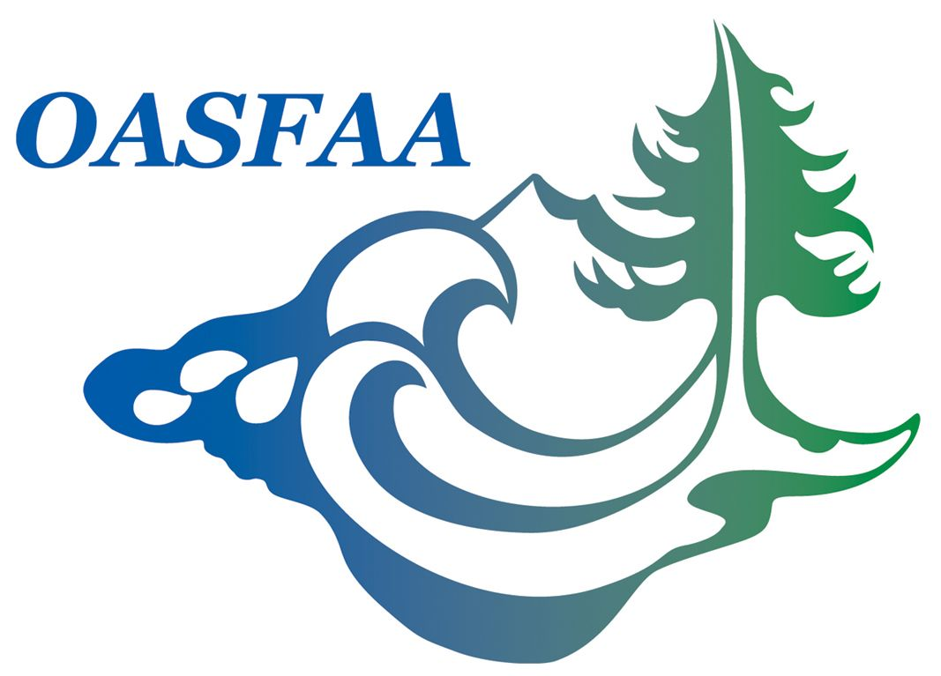
Executive Council Meeting
March 29, 2011
Chemeketa Community College – Salem, OR

MEMBERS PRESENT: Bert Logan (PCC) - President, Patti Brady-Glassman(OSU) – Past President,
Karen Fobert (Lewis & Clark)–Treasurer, Heather Hall Lewis (UofP) – Treasurer Elect,
Russell Seidelman (UofP)– Vice President 4-yr Private, Elaine Robinson (Linn Benton CC) – Vice President Community Colleges, Kim Pearson (Concorde Career)– Vice President Proprietary,
Kim Lamborn (WOU) – Vice President 4-yr Public, Theresa Schierman (George Fox) - Secretary,

CALL TO ORDER: Meeting called to order by President Bert Logan

WELCOME AND INTRODUCTIONS: New officers introduced to Council

TREASURER’S REPORT: Presented by Karen Fobert
Motion to “accept” report – Patti Brady-Glassman, 2nd – Heather Hall Lewis

*Report approved with amended date on CD

MEETING OBJECTIVE: Confirm the annual budget and committees for the 2011-12 year
(Patti mentioned that in previous years, the committee chairs submitted their budget proposals prior to EC meeting to confirm annual budget.) It was decided that we would review the current budget and make proposals to the committee chairs. The Committees can evaluate their goals to determine whether additional funding is needed and justified.

FUND DEVELOPMENT COMMITTEE: Chair - Robert Rogers has volunteered for this position. A school representative is needed to work with Robert. It is expected that 10K can be raised through development. Karen will need to work with the committee to determine how the funds are allocated. (tables, advertising, etc.)

OASFAA CONFERENCE: Michelle Holdway and Ryan West have agreed to co-chair the 2012 OASFAA Conference. It was recommended that we keep registration fees @ $210 for “Early Bird” and $245 for late registrations. Anticipate $36,750 revenue from registrations for 2012 Conference. (Assumes 175 attendees @ $210 each.)

SITE SELECTION: Patti Brady Glassman

DIRECTOR TRAINING: determined as not necessary when WASFAA offers it, and OASFAA doesn’t have anyone to lead it.

TRAINING BUDGET FOR EC: Wasfaa = $2300, Leadership Training = $1700 x 2 = $3400 (Treasurer & Pres. Elect) $5700 proposed for EC Training budget.

FA 101 – Mike Johnson and Kathy Campbell

FA 201 –

SUPPORT STAFF WORKSHOP – Nancy Hanscom, Dolores Pruitt

SUMMER DRIVE-IN: Tracy Lehman

MENTORING: Sue Shogren & Lilly Fox – Bert will ask for proposal of goals and expenses.

LEADERSHIP TRAINING: Leslie Limper – Proposal of goals and expenses.

VOLUNTEER COORDINATOR: Nancy Hanscom

OUTREACH: Committee Chair Needed
* Bert will ask Judy Saling for proposal and revenue or expense associated with outreach.

NEWSLETTER: Sue Shogren

LEGISLATIVE: Janet Turner (University of Portland), Geoffrey S Wullshlager (Portland State University)

OSAC LAISON: Josette Green, Susan Degen

MEMBERSHIP: Stacie Eglund

REGISTRATION: Heather ? (ATAK)

TECHNOLOGY: Judy Saling, Ben Wessell

STRATEGIC PLANNING: Donna Fulton

VENDOR LIAISON: Cherrie Champie

*Karen Fobert made notes of all budget recommendations.

**PROPOSAL TO INCREASE MEMBERSHIP DUES FROM $25.00 TO $30.00. Patti indicated a dues increase would need to meet the approval (vote) of membership.

**Next Meeting in April….Bert will need to look at his calendar as now is in transition working in two locations having accepted the position at PCC.

MOVED TO ADJOURN: Moved by ?
Seconded by ?

