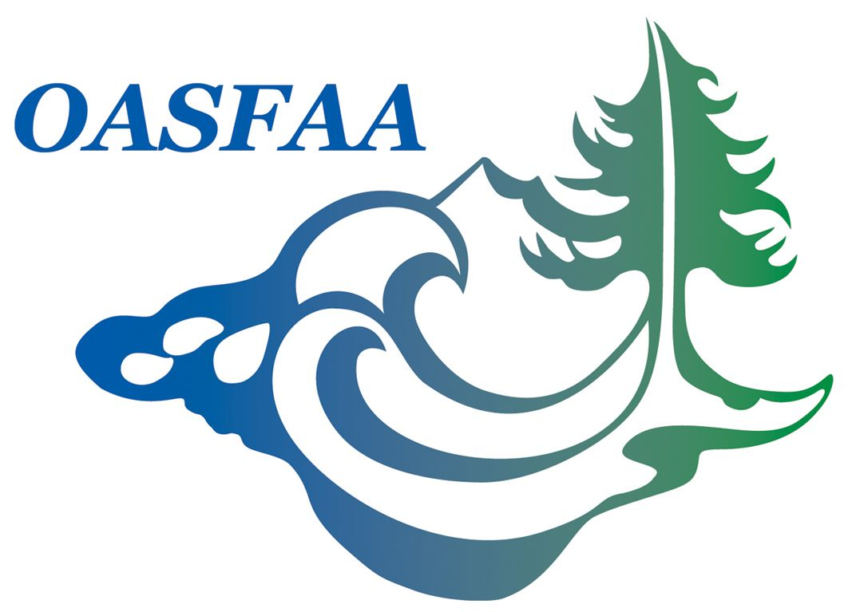

OASFAA Annual Business Meeting
February 4th, 2011
Salishan Lodge

CALL TO ORDER:
OASFAA President, Patti Brady-Glassman called the meeting to order.

APPROVAL OF MINUTES:
Minutes Donna Fossum moved to approve the minutes from the January 26, 2010 Business Meeting. The motion was seconded by Mellony Stratton. Motion carried.

TREASURERS REPORT: Karen Fobert
Karen e-mailed “electronic” copy of the “Treasurer’s Report” to all conference attendees in the interest of sustainability. She reiterated that we “appear to be on track to meet or nearly meet our budgeted income for the year”. Karen thanked the past EC committee members for having the fiscal foresight to build up our reserves. We have adequate reserves to cover our future annual conference contract commitments.
Karen also took time to thank our generous exhibitors and sponsors for their continued support of OASFAA.
Exhibitors: SunTrust, US Bank, Great Lakes, Nelnet, Citibank
Sponsors: USA Funds, Wells Fargo and ECMC
Melinda Dunnick moved to “approve” the report. Motion seconded by Katrina Schmidt

PRESIDENT’S REPORT: Patti Brady-Glassman
OASFAA’s Executive Council finalized a budget that would allow us to continue providing quality training and assure that we continue to maintain a fiscally sound organization. The majority of our income now stems from OASFAA membership dues. Patti extended thanks to Raymond Yee and Mike Johnson for their success in securing $11,000 from vendors for this year’s conference. Patti reiterated OASFAA’s appreciation for the generous support of our vendors. (All mentioned in the Treasurer’s Report) Patti also thanked our friends at the Ford Family Foundation for all that they do to support students, but also for their continued support of OASFAA.

This years’ total membership, through the efforts of Membership Chair, Stacie Englund, exceeds last year’s membership totals. We have 316 current members, 252 of which are renewed members, 64 are new to OASFAA.

Page 2

OASFAA Annual Business Meeting cont.

Patti complimented Sue Shogren’s commendable job as the newsletter editor and for spearheading the creation of the OASFAA brochure, which will be used for outreach purposes.

Patti introduced Nancy Hanscom who graciously accepted the newly created “Volunteer Coordinator” position for OASFAA. We hope to expand our volunteer base by providing better communication and outreach to members through the Volunteer Coordinator position.

Patti, with the help of Donna Fossum, presented numerous awards and certificates of appreciation to officers and committee members. She then presented the gavel and “Sage Box” to incoming President Bert Logan. Bert presented a plaque honoring Patti for her service as OASFAA President.

Bert addressed the membership sharing his thoughts and inspirations of having chosen Financial Aid as his “vocation.

He introduced the Executive Council for 2011-12.

President-elect – Donna Fulton, Klamath Community College
VP Community Colleges – Elaine Robinson, Linn Benton Community College
VP Private Four Year – Russell Seidelman, University of Portland
VP Proprietary Schools – Kimberly Pearson, Concorde Career Institute
VP Public Four Year – Kimberly Lamborn, Western Oregon University
Secretary – Theresa Schierman, George Fox University
Treasurer-Elect – Heather Hall Lewis, University of Portland

There was no “old” or “new” business brought to the floor.

Bert adjourned the meeting.

Next Conference will be held at Salishan, February 1st-3rd, 2012

