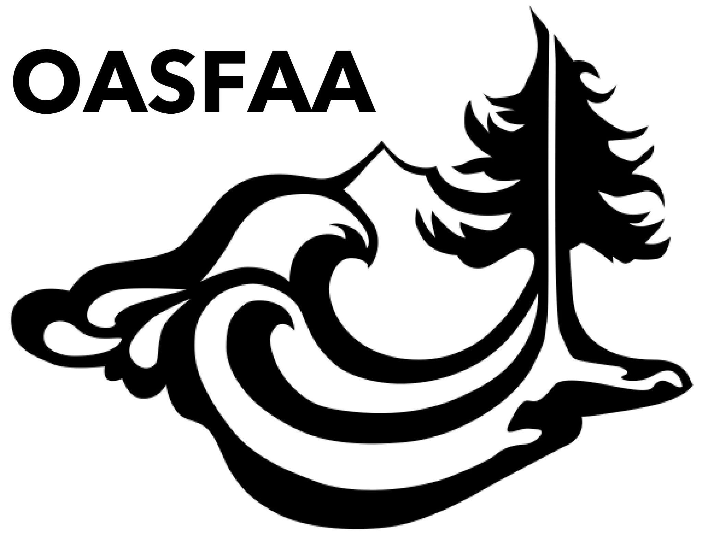
OASFAA Officer/Committee Report

Meeting Date:
Committee:
Chairs/Officer Name:

Strategic Plan Goals & Strategies (PDF):
Topic Area | Goal | Strategies
Operations | C.1 | Develop robust communication engagements to promote OASFAA activities, and inform membership of local, state, regional and national news.

Current Year Goals:

Recent Activities:

Budget:

Questions/Issues for Executive Council Feedback:

