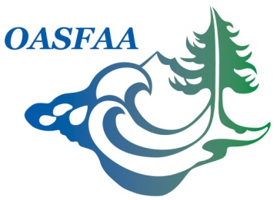

OASFAA High School Counselor Training
Committee Report
July 18, 2017

Committee Co-Chairs:
Jennifer Satalino – ECMC
Molly Walsh - University of Portland

Committee Volunteer Nominees:
- Karinda Decker - Southern Oregon University
- Jason Hibbert - Eastern Oregon University
- Brenna Sylwester - Central Oregon Community College
Goals:

- Collaborate with educational stakeholders to provide financial aid training to Oregon high school students, high school and college counselors and mentors.
- Provide presenters, materials and training for the four Oregon University System (OUS) counselor training events throughout the state as well as the ASPIRE Conference in October.
- Create a centralized OASFAA speakers databased for community access in order to find event speakers and presenters.
  - Would like support from EC to potentially create new OASFAA listserve for speakers database
- Created vetted, stock presentation for events were OASFAA members are unable to present or attend.
- Create an online financial aid video presentation, accessible to the community at large for use at high school events and financial aid nights.

Recent Activities:

- Met on 7/17/17 to discuss high school counselor trainings for year
  - Four OUS trainings : 10/17 OUS @ Eastern Oregon (Jason Hibbert covering), 10/19 OUS @ Oregon Tech (Karinda Decker), 10/24 OUS @ Portland State (Molly/ Jenn), 10/25 OUS @ Oregon State (Molly/ Jenn).
  - Oregon School Counselor Association Conference, 10/13 – Jenn is going to submit a session
  - Aspire @ Lann Community College November 3rd (Molly/ Jenn)
- Working on getting list serve up. Going to put a request out to membership for volunteers to sign up.
- Worked on finalizing and updating a stock presentation to have available for community members and volunteers from OASFAA as well as event presentations.
Budget: $1,500

