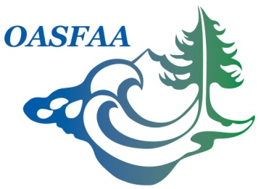

OASFAA Volunteer Committee Report
May 27, 2016

Committee Chair: Ashley Coleman, University of Oregon

2016-2017 Goals:

- Consider ways to recognize volunteers throughout the year
- Work with Conference Committee and EC to award certificates to all volunteers at the 2017 Annual Conference

Recent Activities:

- Since the last meeting on 3/15/16, we have had 14 people express volunteer interest
  - I want to ensure that all volunteers are being emailed by committee chair, even if their services cannot be utilized by your committee this year
- Emailed membership on 3/16 with instructions on how to update volunteer preferences
- Emailed EC on 3/24 with instructions on how to view potential volunteers via the OASFAA website
- Submitted a Volunteer Spotlight featuring Jessica Steinhebel for the next newsletter
- Emailed the EC on 5/11/16 with instructions on how to post minutes & reports to the OASFAA website
- Worked with a colleague in my office to organize a Eugene/Springfield OASFAA event, which we hope to do quarterly
  - Sent Google poll to gauge interest
    - 23 respondents, most interested in quarterly event such as bowling, mini golf, family friendly options, food, winery, etc
  - The first event will be bowling at Emerald Lanes on 6/17 from 5:30-7pm
  - We are sending invitations to all OASFAA schools & organizations in the area

Budget: Unknown

